Tectonics - Collision Boundaries

Collision Boundaries
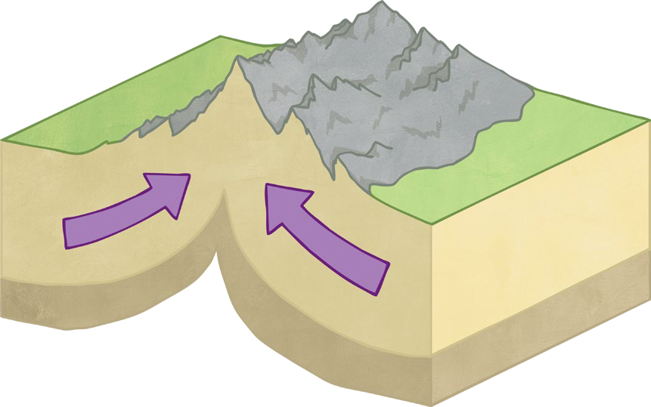

Complete the paragraph:
Collision boundaries occur when two continental plates are moving each other. The plates move extremely but, over millions of years, the crust is forced upwards and
form. The Himalayas mountain range is an example of this. As well as the slow creation of this landform, this plate boundary is also known for very large .
Tectonics - Collision Boundaries

Maps from Memory

Look at the diagram of a collision plate boundary for 30 seconds.
Fold this sheet over or cover up the diagram and then then draw a sketch of it in the box below from memory.
You can refresh your memory for another 30 seconds if you’re stuck – but then finish your sketch.

